Ryan Prinsen

Module 5.2 Assignment

April 16, 2023

GitHub Link: <https://github.com/ryanprinsen66/csd-340.git>

The Subject: Liam Prinsen: Interview

1. What is your birthday?

Answer: April 11th, 2011.

1. Where do you live?

Answer: I live part-time in Hudson, Wisconsin and Blaine, Minnesota.

1. What grade are you in?

Answer: Sixth Grade.

1. What are your favorite subjects in school?

Answer: Math and Science

1. What are your favorite things to do/hobbies?

Answer: Hanging out with friends, writing code/game development, playing Roblox, diamond art, watching movies/shows, and watching TikTok.

1. What are some interesting things about you?

Answer: I have memorized pi up to 22 decimal places.

1. What are your favorite colors?

Answer: Orange, Red, and Blue.

1. What are your top 5 favorite shows/movies?

Answer:

Shows:

* Stranger Things
* The Flash
* Upload
* Supergirl
* The Thunderman’s

Movies:

* Harry Potter (All of Them)
* Avengers (Infinity War & Endgame)
* Spiderman
* Shazaam
* Fight Club

1. What do you want to be be when you get older?

Answer: Game Designer, Stock Investor, Veterinarian

1. What is an accomplishment you are really proud of?

Answer: I made a rock-paper-scissors game on Code.org Applab using 289 lines of code.

1. What is your favorite memory?

Answer: So this one time, I was playing hide & seek with my older siblings. My brother locked my sister in a room, and I unlocked it so she could get out. I had to use the restroom so I told my sister I had to go do something and I would be back shortly. After I took a few steps, I was hit with an intense pain. I looked down and realized there was a tack in my foot. This was a few years ago so I started crying. When my sister came and found me, she realized I was crying, and was convinced that when I told her I had to go do something, the thing I needed to do was cry.

Biography:

Liam Prinsen was born on April 11th, 2011 in River Falls Wisconsin. He has lived most of his life in Hudson Wisconsin where he attends school, and currently lives part-time in Blaine, Minnesota as well. At school, his favorite subjects are Math and Science, as well as pretty much any class having to do with coding or computer programming. He has aspirations to do something in the field of computer programming—specifically something in the realm of game design—but is also interested in being a veterinarian or a stock investor.

In his free time, Liam enjoys spending time with his friends—developing code with them, trying to develop games, watching shows or movies, or playing video games such as Roblox. He mentioned that he is particularly proud of a Rock-Paper-Scissors game that he was able to develop using 289 lines of code on the website: Code.Org in App Lab. He also enjoys doing Diamond art, doing puzzles, playing on his phone, and watching TikTok. Liam also loves playing many different board games, with his favorite being Monopoly.

Liam is really into watching movies and television shows mainly within the realm of science fiction and fantasy. He particularly enjoys movies or television shows that contain supernatural elements and explosive action. A great night is a night where he can curl up with some snacks, turn the television up, and watch some of his favorite shows or movies. He even keeps a list of his top 5 favorite movies and shows, which can be seen within the Hobbies page.

Selected Color Palette: 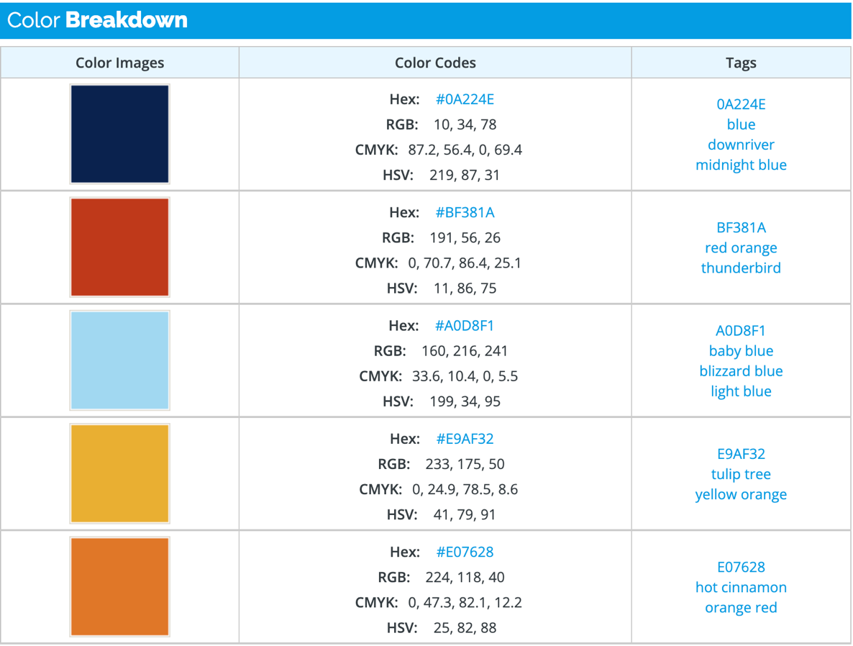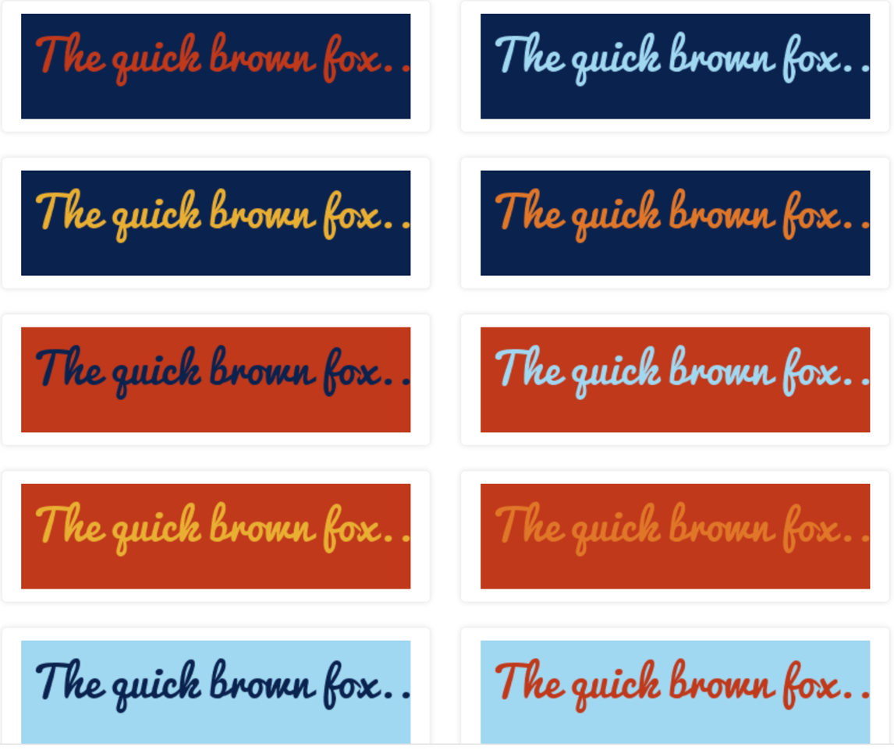

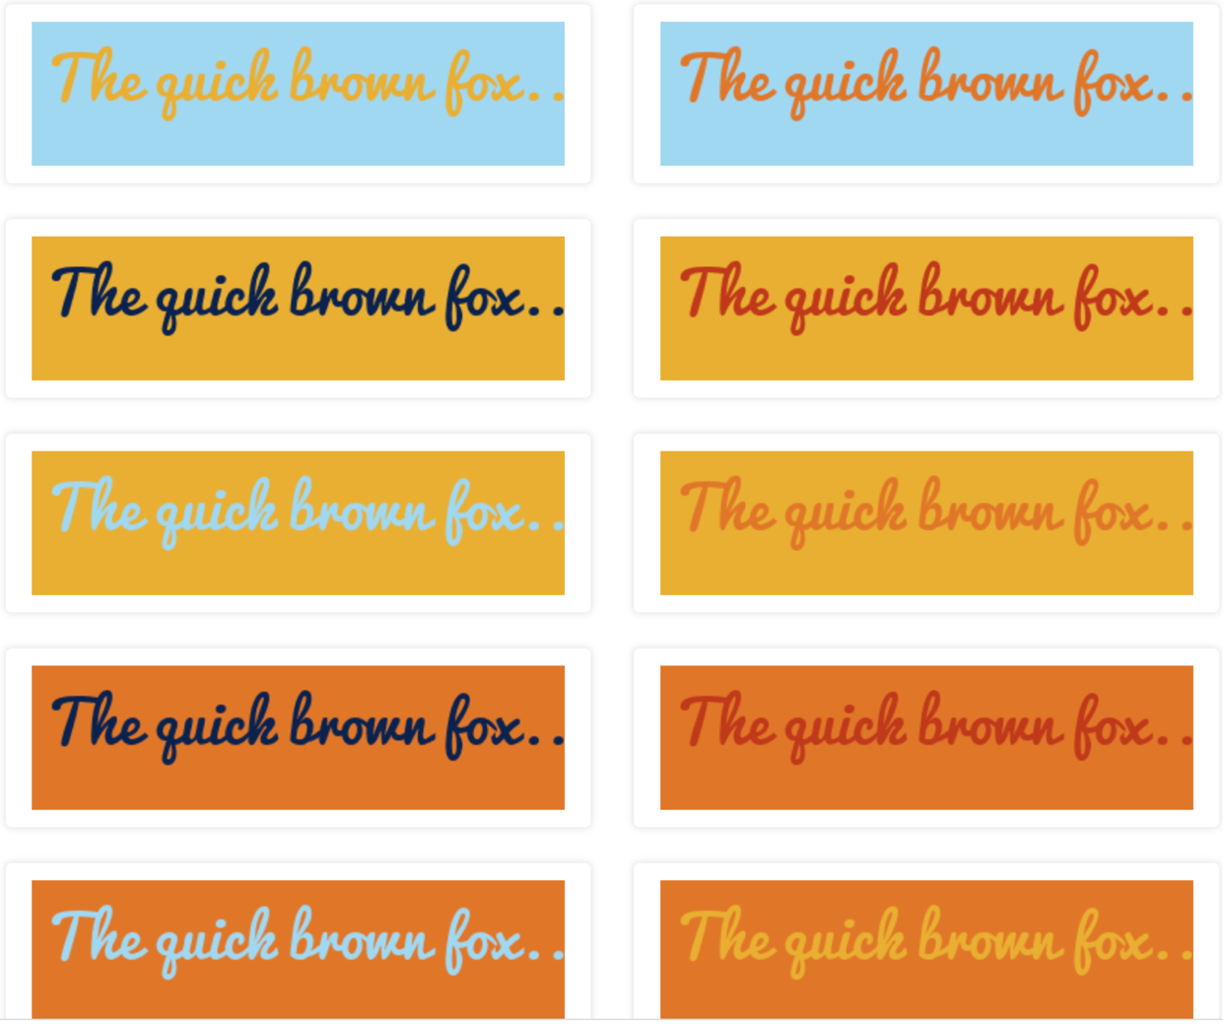

Images:

Hobby Images:



Figure 1: Hobby Roblox

Top 5 Shows/Movie images: Hobbies



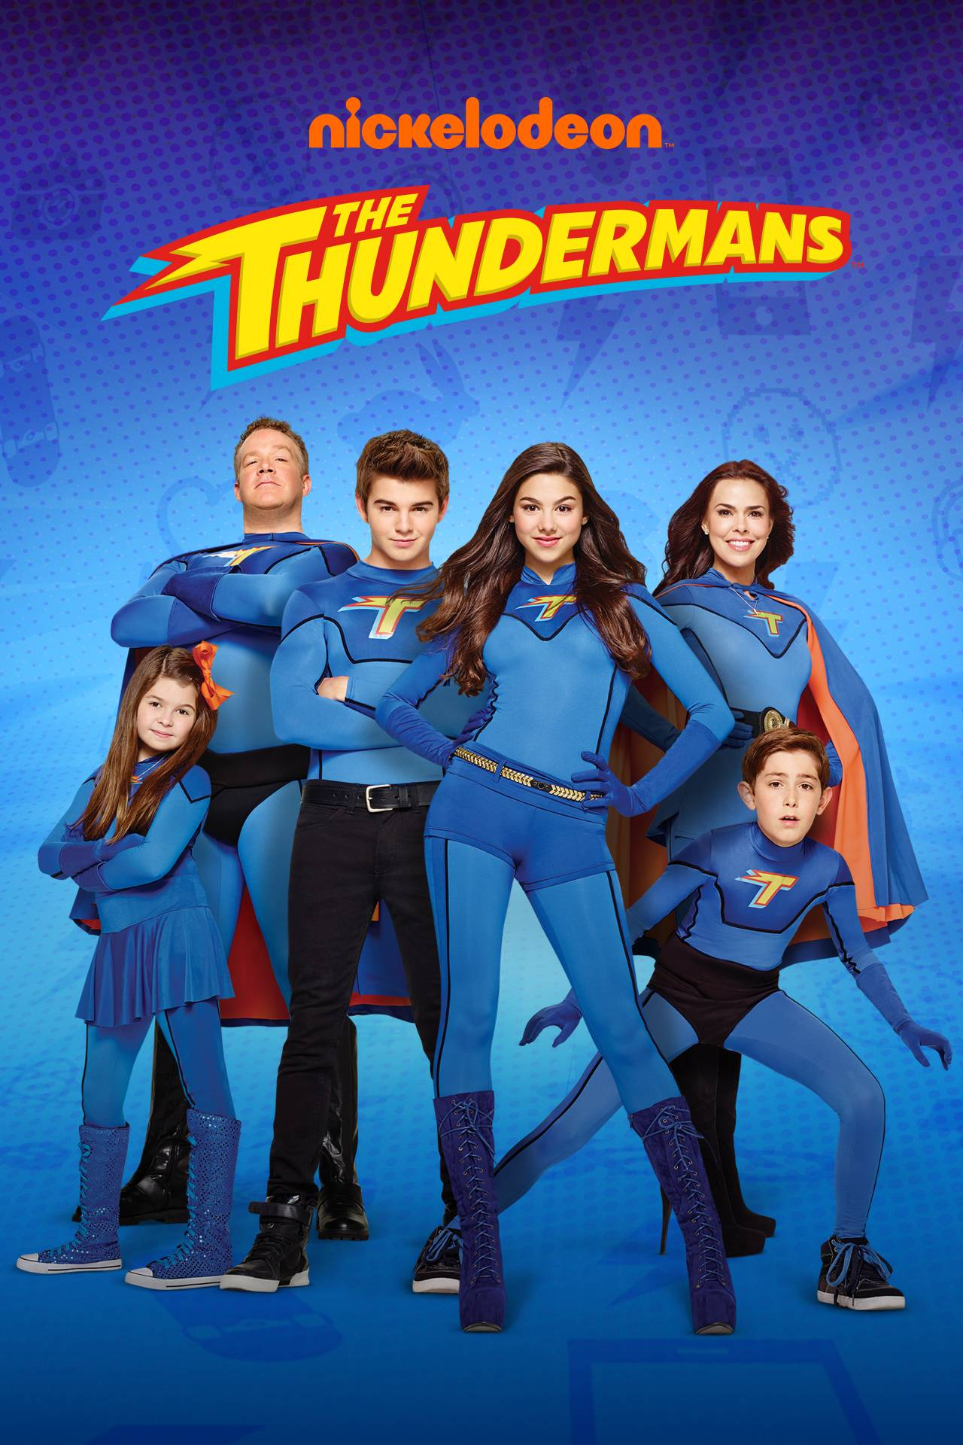

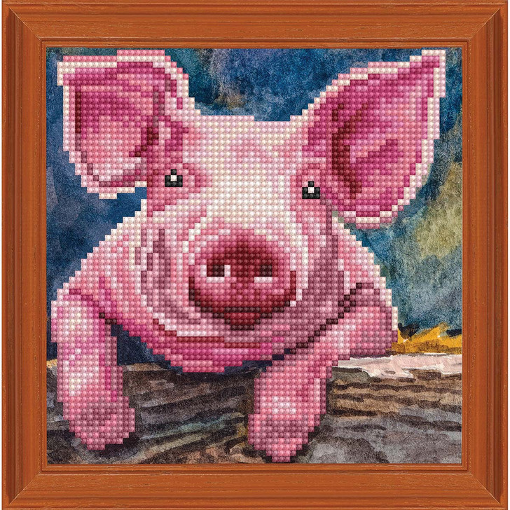

Figure : Doing diamond art: Hobby

Images: Selfies



Figure : Main Photo



Figure : For Bio as it talks about growing up. 1



Figure Figure 2: For Bio as it talks about growing up. 2



Figure : Goal to be Vet: Goals



Figure : Stock Broker: Goals



Figure : Game Designer: Goals

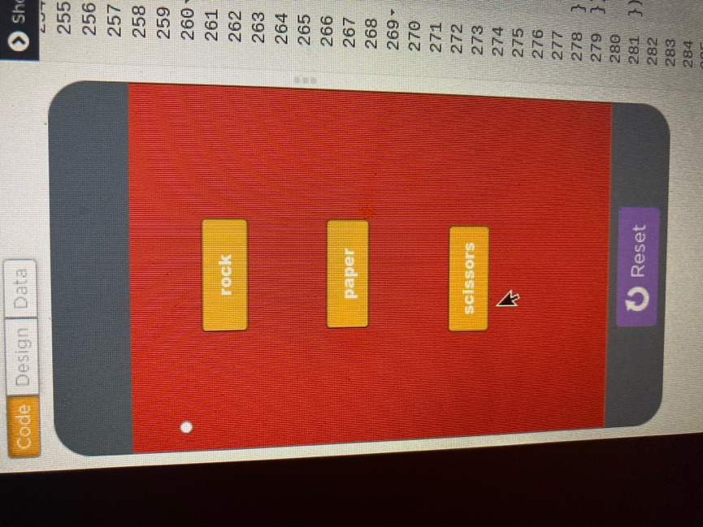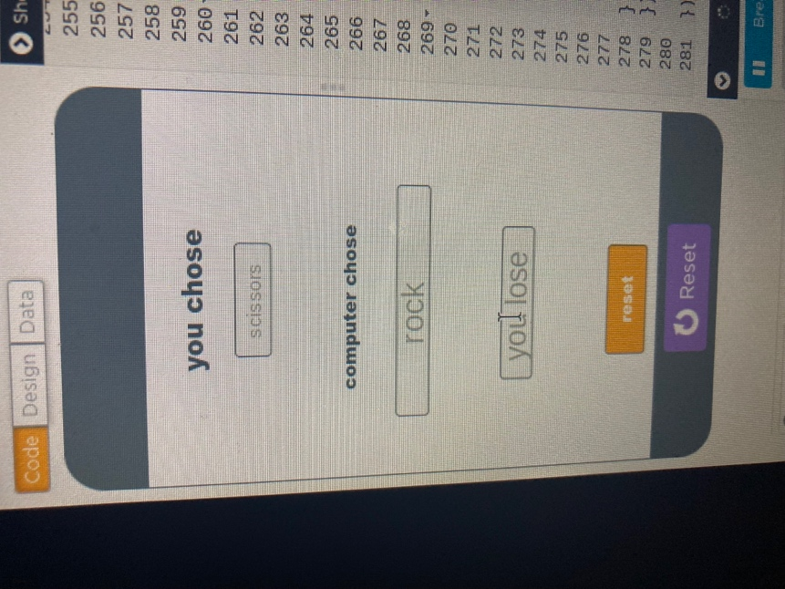

Hobbies:: Rock Paper Scissors (Accomplishment) 1. Hobbies:: Rock Paper Scissors (Accomplishment) 2

**Style Sheet: HTML doc stating guidelines: This is a work in Progress.**

<!-- Ryan Prinsen : Assignment Module 5.2 -->

<!DOCTYPE html>

<html lang="en">

<head>

<link rel="stylesheet" href="Prinsen_Mod5_2.css" type="text/css"/>

<title>CSD 340 Web Development with HTML and CSS</title>

</head>

<body>

<div id="container">

<h1>Biosite HTML & CSS Front-End Stylesheet</h1>

<h2>General Typography</h2>

<h3>Font Type</h3>

<p>font-family: comic sans ms</p>

<hr>

<h2>Headings</h2>

<h3>h1 Element</h3>

<p>The <strong>h1</strong> element are to be used as the page header only. They should only be used once per page. They should be centered within the page. The size should be the default size. Check the title at top of the page for an example. </p>

<hr>

<h3>h2 Element</h3>

<p>The <strong>h2</strong> element should be used as the headers for main sections. This should also be centered using "text-align: center;". The size should be default size. Check the -General Typography- title located underneath the page title at the top of the page for an example.</p>

<hr>

<h3>h3 Element</h3>

<p>The <strong>h3</strong> element should be used for all remaining header types that are not included in the h1 and h2 element guidelines. The size should remain at default size. Check the section title--h3 Element-- for an example.</p>

<hr>

<h2>Other General Formatting</h2>

<h3>Paragraph</h3>

<p>All paragraphs are to be wrapped in <strong>p</strong> tags.</p>

<hr>

<h3>Horizontal Rule</h3>

<p>The <strong>hr</strong> element is to be used to separate sections within the page, or to separate paragraphs. Check examples below:</p>

<hr>

<h3>Figures</h3>

<p>The <strong>figure</strong> element is to be used to annotate any media, or citations. Check example below:</p>

<hr>

<h3>Citations</h3>

<p>The <strong>cite</strong> element is to be used for any works that need to be credited to another individual such as a book, or video, etcetera...</p>

<hr>

<h2>Lists</h2>

<h3>Ordered Lists</h3>

<p>The title of the List should use the h3 tag. Ordered lists are denoted with the <strong>ol</strong> element, and the <strong>li</strong> element is to surround the list items. Lists should be wrapped in a <strong>div</strong> tag. The numbering of the list items should be like the example below:</p>

<div id="divName 1">

<h3>List Example</h3>

<ol>

<li>List item 1</li>

<li>List item 2</li>

<li>List item 3</li>

</ol>

</div>

<hr>

<div id="div name 2">

<h3>Unordered Lists</h3>

<p>The title of the List should use the h3 tag. Ordered lists are denoted with the <strong>ul</strong> element, and the <strong>li</strong> element is to surround the list items. Lists should be wrapped in a <strong>div</strong> tag. The unordered list should not be numbered, and should use bullet points like the example below: example below:</p>

<h3>List Example</h3>

<ul>

<li>List item 1</li>

<li>List item 2</li>

<li>List item 3</li>

</ul>

</div>

<hr>

<h2>Link Formatting</h2>

<h3>Links</h3>

<p>Links should be wrapped in a <strong>div</strong>. A link should be underlined when hovering over: <strong>a:hover: text-decoration: underline;</strong>. The color of the link should change after the link has been visited. Check the example below:</p>

<div id="divName3">

<a href="https://ryanprinsen66.github.io/csd-340/">Back to Landing Page</a>

</div>

<hr>

<h2>Color Palette Information</h2>

<h3>Color Palette</h3>

<p>The chosen colors Hex #'s for the page are as follows: #0A224E, #BF381A, #A0D8F1, #E9AF32, and #E07628.</p>

<div id="color1">

<figure>

<img src="images/color4.png" width="500" height="600"/>

<br />

<figcaption>

<cite>(Colorcombo416 with hex colors #0A224E #BF381A #a0d8f1 #E9AF32 #E07628. ColorCombos.com. (n.d.). Retrieved April 16, 2023, from https://www.colorcombos.com/color-schemes/416/ColorCombo416.html)</cite>

</figcaption>

</div>

<div id="color2">

</figure>

<figure>

<img src="images/color2.png" width="500" height="600"/>

<br />

<figcaption>

<cite>(Colorcombo416 with hex colors #0A224E #BF381A #a0d8f1 #E9AF32 #E07628. ColorCombos.com. (n.d.). Retrieved April 16, 2023, from https://www.colorcombos.com/color-schemes/416/ColorCombo416.html)</cite>

</figcaption>

</div>

<div id="color3">

</figure>

<figure>

<img src="images/color1.png" width="500" height="600"/>

<br />

<figcaption>

<cite>(Colorcombo416 with hex colors #0A224E #BF381A #a0d8f1 #E9AF32 #E07628. ColorCombos.com. (n.d.). Retrieved April 16, 2023, from https://www.colorcombos.com/color-schemes/416/ColorCombo416.html)</cite>

</figcaption>

</div>

</div>

</body>

</html>

**CSS StyleSheet for Above Guidelines:**

body {

background-color: #A0D8F1;

color: #BF381A;

font-family: "comic sans ms";

font-weight: 100px;

}

h1 {

text-align: center;

}

h2 {

text-align: center;

}

H1, h2, h3 {

color: #0A224E;

text-decoration: underline;

}

#color1, #color2, #color3 {

text-align: center;

}

a:link {

color: #E07628;

text-decoration: none;

}

a:visited {

color: #E07628;

text-decoration: none;

}

a:hover {

text-decoration: underline;

}

figcaption {

color: #E07628;

font-size: 12px;

text-align: center;

font-weight: bold;

}

hr {

border-color: #E9AF32;

}

ul {

list-style-type: circle;

}

Example Stylesheet guidelines Webpage per above HTML & CSS Code:

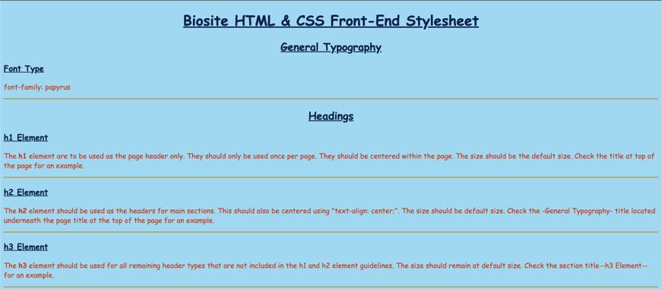

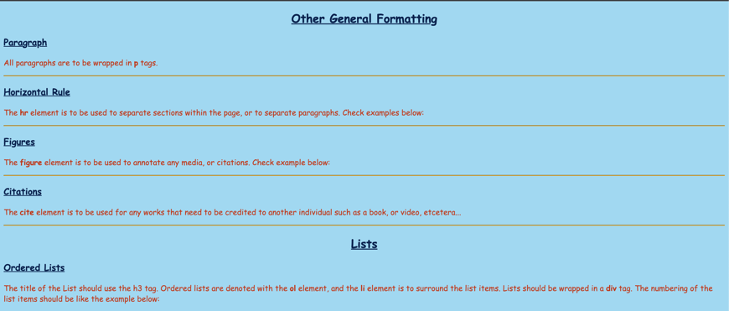

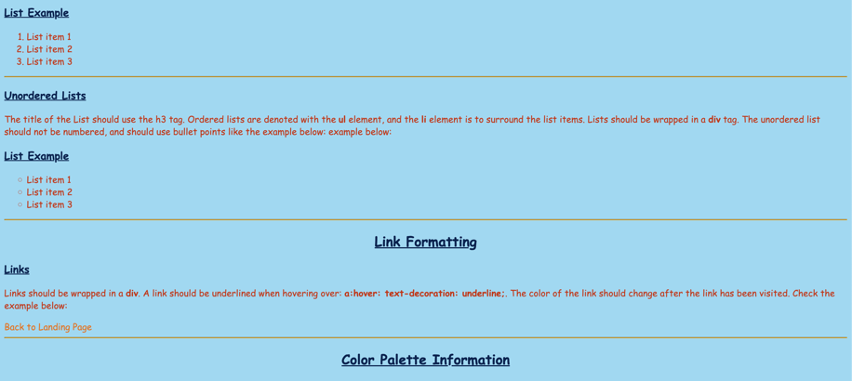

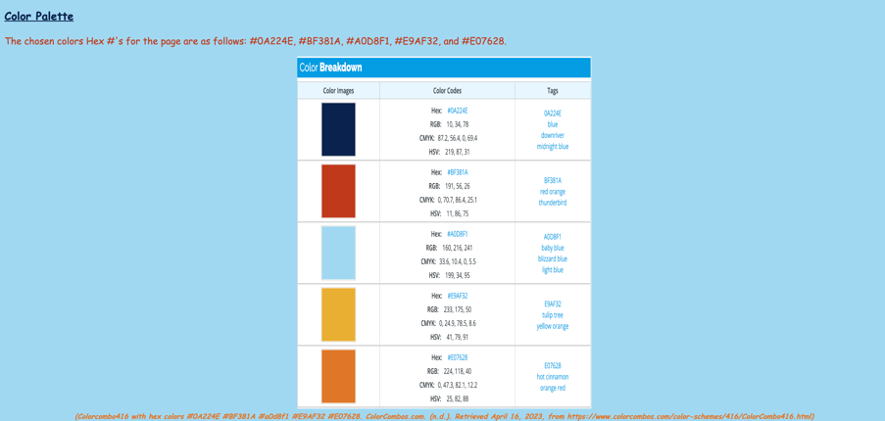

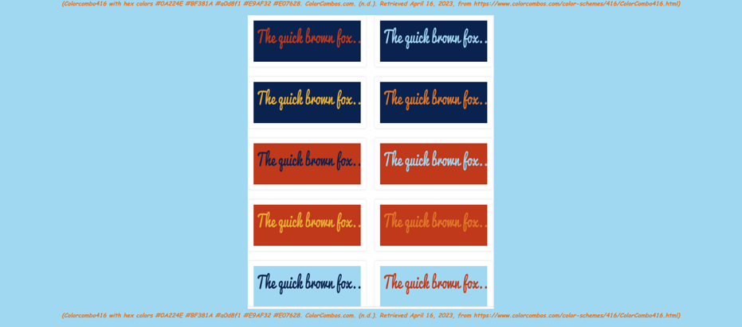

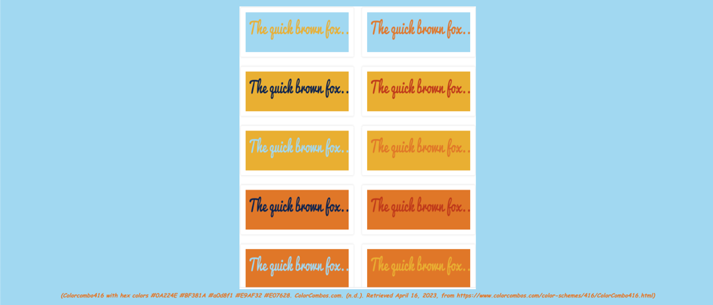

Sketches/WireFrames